WEEK 3 LAB “Weather_api”

Krish Gurung
ID: 2652393

4.6 API Testing and Access Objective Test the API’s functionality.

Task • Make the development server’s port public via Codespaces.
• Access the API in a web browser using the API URL similar to: http://yourcodespaces.com/api/weather/london

NOTE: replace: "yourcodespaces.com" with your actual URL You can also use SwaggerHub to interact with your API by modifying the SwaggerHub URL to your development server’s URL.

Outcome
Successfully tested and accessed the API.

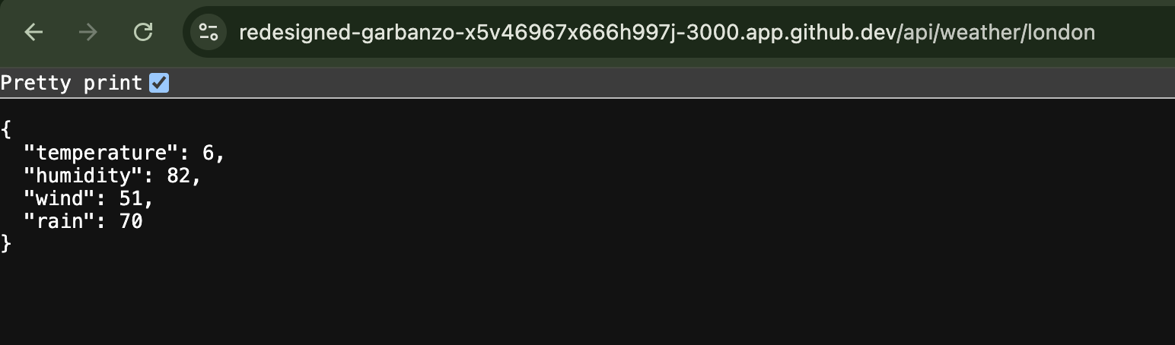

4.7 Enhancing the Service Layer Objective Add functionality to the API.
Task
• In the services/weatherService.ts file, create functions to fetch temperatures for two additional cities.
• Update existing controller logic to accommodate these new functions.

Dubai and Paris were added.

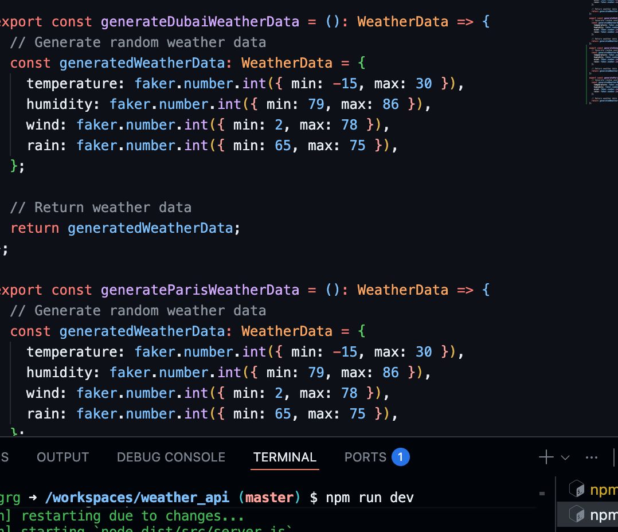

Outcome
Extended API functionality with more city options.

Dubai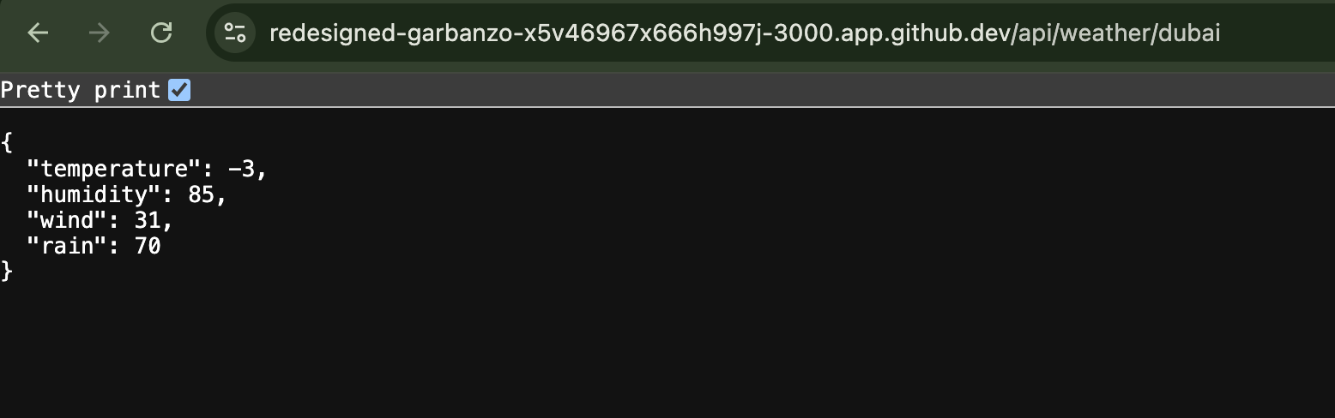

Paris
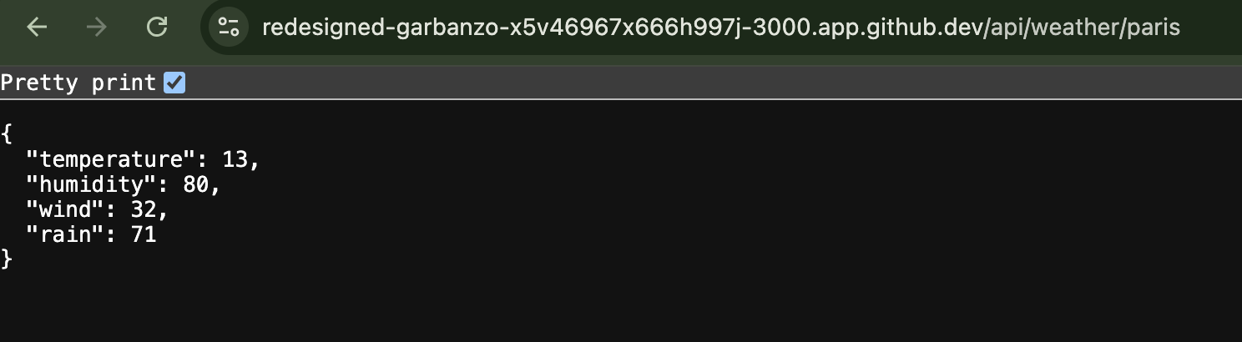

4.8 Creating a New API Route Objective Implement a new feature in the API.
Task
• Define a new route that returns a three-day temperature forecast for London in the format:
{ dayOne: 14, dayTwo: 23, dayThree: 17 }

• Ensure TypeScript types are created and the new route adheres to the existing API structure.

Outcome
A new functional API route providing a three-day forecast.
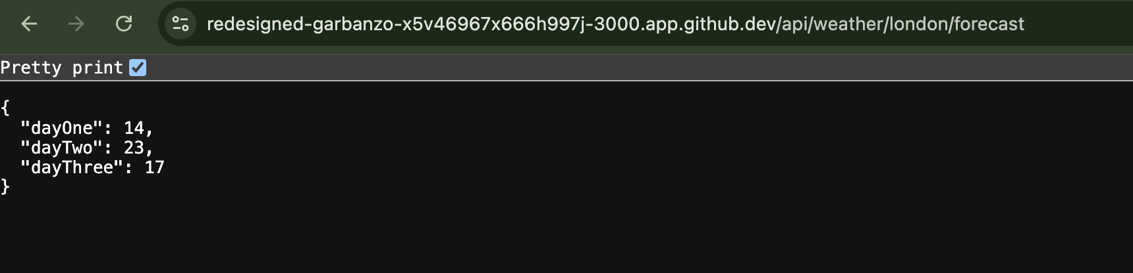

4.9 Updating the API Documentation and Testing Objective Keep your API documentation accurate.
Task
• Update the OpenAPI Specification on SwaggerHub to reflect the new changes and routes in your API.
• Test the new API using SwaggerHub or the browser.

Outcome
An up-to-date and accurate API documentation on SwaggerHub.

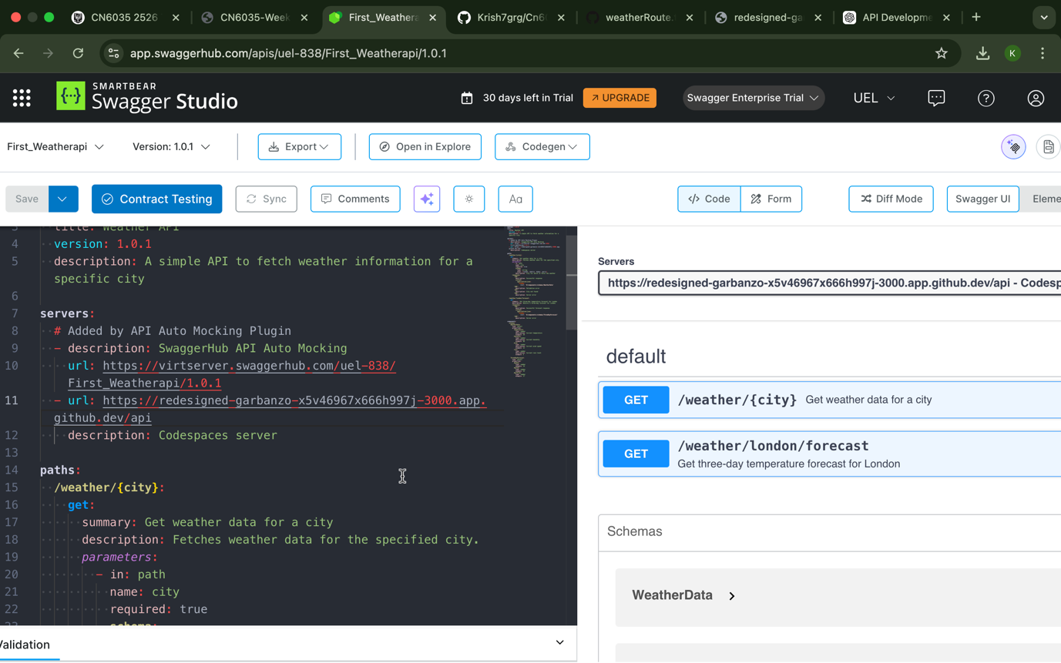

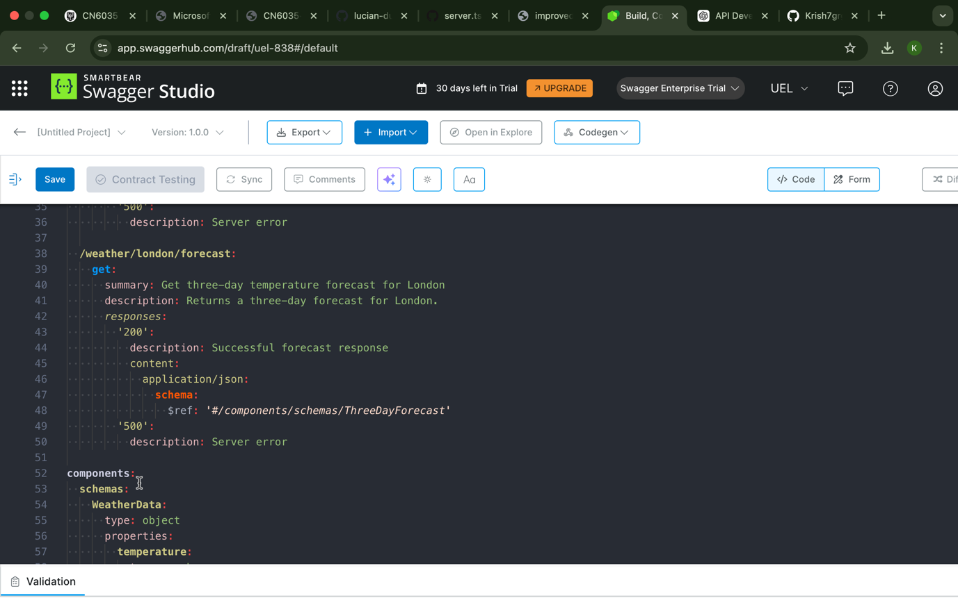

Test

For city
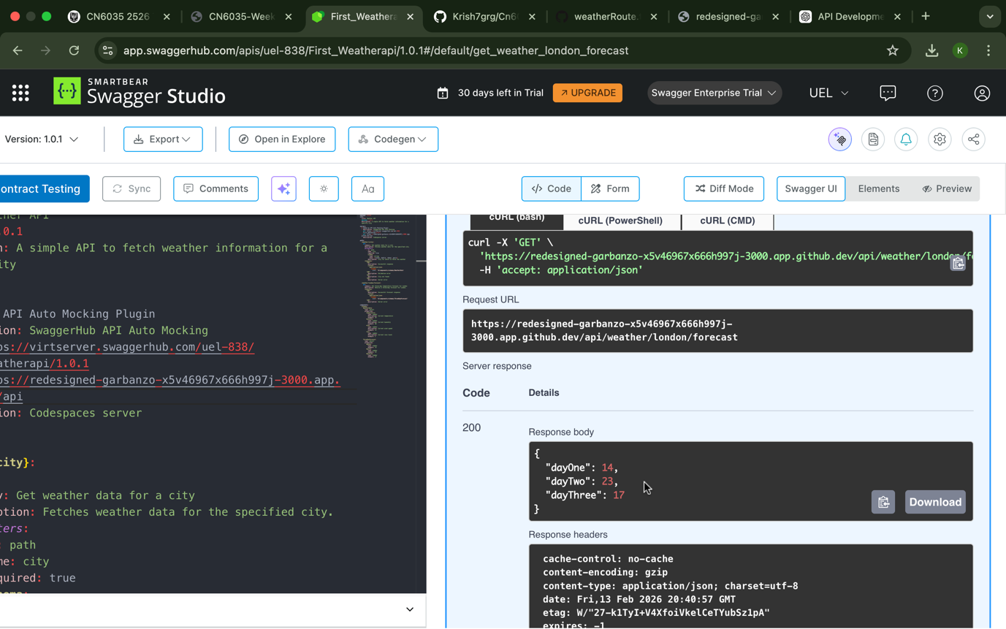

For London forecast
